1. To demonstrate the following string functions :

i) strcmp

ii) strcat

iii)strcpy

Code:

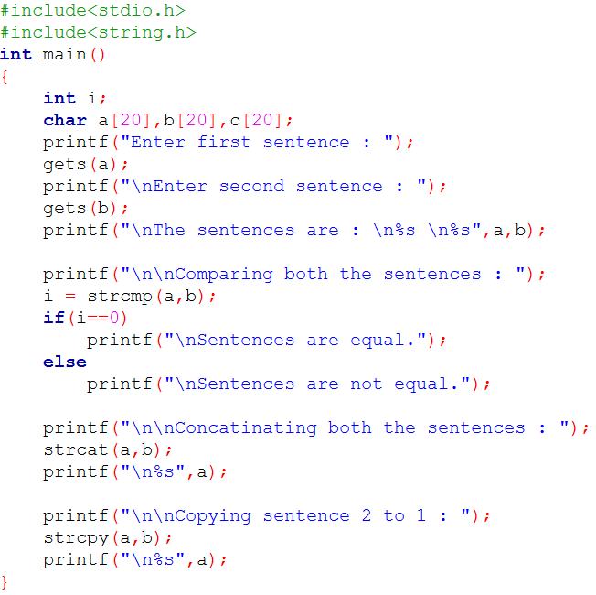

Output:

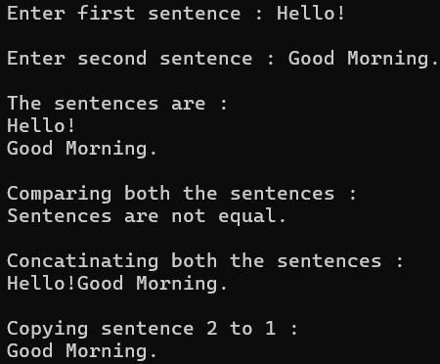

2. Find the length of the string without using library functions.

Code:

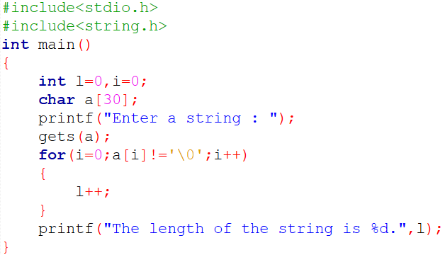

Output:



3. Count the number of vowels in a string.

Code:

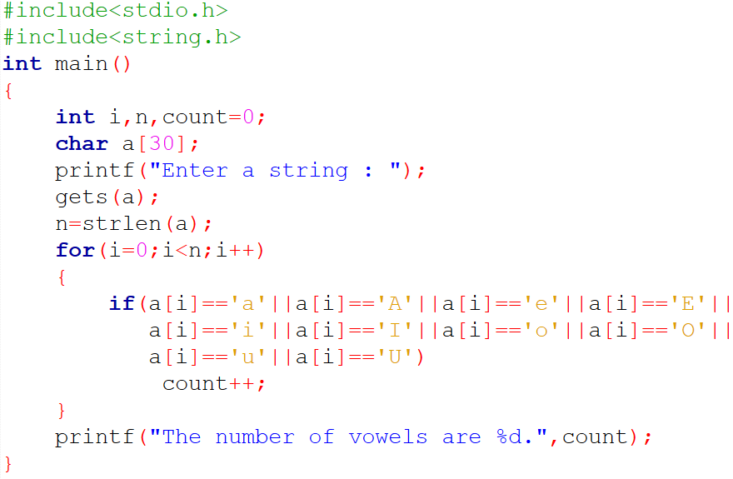

Output:

